.

📘 Notes: Spark Declarative Pipelines

⭐ 1. What Are Spark Declarative Pipelines?
Spark Declarative Pipelines (mainly used in Delta Live Tables) are a way to build data pipelines where you declare what you want, and Spark automatically handles how to do it.

🔹 Simple Definition:
A declarative pipeline means:
👉 You only write the logic of transformation
👉 Spark automatically handles execution, optimization, scheduling, and dependency management
You declare the tables, transformations, logic, and Spark builds the pipeline for you.

⭐ 2. Why Declarative? (Purpose)
Declarative pipelines remove the complexity of:
- Writing manual ETL job logic
- Managing job order (what runs first)
- Handling incremental loads
- Handling failures
- Cleaning and validating data
- Optimizing the ETL pipeline
Spark + DLT does everything behind the scenes.

🔹 In simple words:
You focus on data logic → Spark handles the entire pipeline automatically.

⭐ 3. Key Features / Uses of Declarative Pipelines

✔️ 1. Automated Data Processing
Spark handles:
- Incremental processing
- Scheduling
- Job ordering
- Writing outputs
- Optimization

✔️ 2. Built-in Data Quality (Expectations)
You can define rules like:
@dlt.expect("valid_amount", "amount > 0")

DLT validates and rejects bad data automatically.

✔️ 3. Auto Dependency Management
If Table B depends on Table A, DLT automatically runs A first.
You don’t need to write orchestration logic.

✔️ 4. Handles Batch + Streaming
DLT supports:
- LIVE TABLE → batch/incremental
- STREAMING LIVE TABLE → real time streaming

✔️ 5. Auto Lineage & Pipeline Graph
DLT shows the entire pipeline visually.

✔️ 6. Production-Ready
Declarative pipelines offer:
- Auto recovery
- Fault tolerance
- Schema evolution
- Backfill support
- Logging & metrics

⭐ 4. Example (Very Simple)

Declarative DLT Code
import dlt
from pyspark.sql.functions import col

# Raw streaming data
@dlt.table
def raw_sales():
return spark.readStream.format("json").load("/mnt/raw/sales")

# Cleaned data
@dlt.table
def clean_sales():
return dlt.read("raw_sales").filter(col("amount") > 0)

# Aggregated data
@dlt.table
def total_sales():
return dlt.read("clean_sales").groupBy("store").sum("amount")

What Spark does automatically:
- Builds pipeline graph
- Tracks dependencies
- Processes only new data
- Updates tables incrementally
- Handles failures

⭐ 5. Why Use Declarative Pipelines?

✔️ Simplifies ETL/ELT
You write logic only — Spark manages everything else.

✔️ Reduces code complexity
No need for airflow, custom orchestration scripts, or manual job dependencies.

✔️ Reliable & Maintainable
DLT-generated pipelines are:
- Clean
- Easy to maintain
- Easily deployable to production

✔️ Better Data Quality
Expectations and schema checks reduce bad data.

✔️ Ideal for both streaming & batch ETL
Can handle:
- Real-time pipelines
- Daily batch pipelines

🎯 One-Line Summary
Spark Declarative Pipelines = You declare transformations → Spark automatically builds, optimizes, schedules, and runs the entire ETL pipeline for you.

If you want, I can also create:
✅ Notes on LIVE TABLE vs STREAMING LIVE TABLE
✅ Notes on Materialized View vs Streaming Tables
✅ Full DLT interview questions

You said:
Notes on different datset in sdp

ChatGPT said:
Here are clear, simple, exam-ready notes on Different Datasets in Spark Declarative Pipelines (SDP / Delta Live Tables).

📘 Notes on Different Datasets in SDP (Spark Declarative Pipelines)
In Spark Declarative Pipelines (SDP) – mainly used in Delta Live Tables (DLT) – datasets represent different types of tables or views that you can declare inside a pipeline.
These datasets define how data is processed, updated, and stored.

⭐ 1. Streaming Table (STREAMING LIVE TABLE)
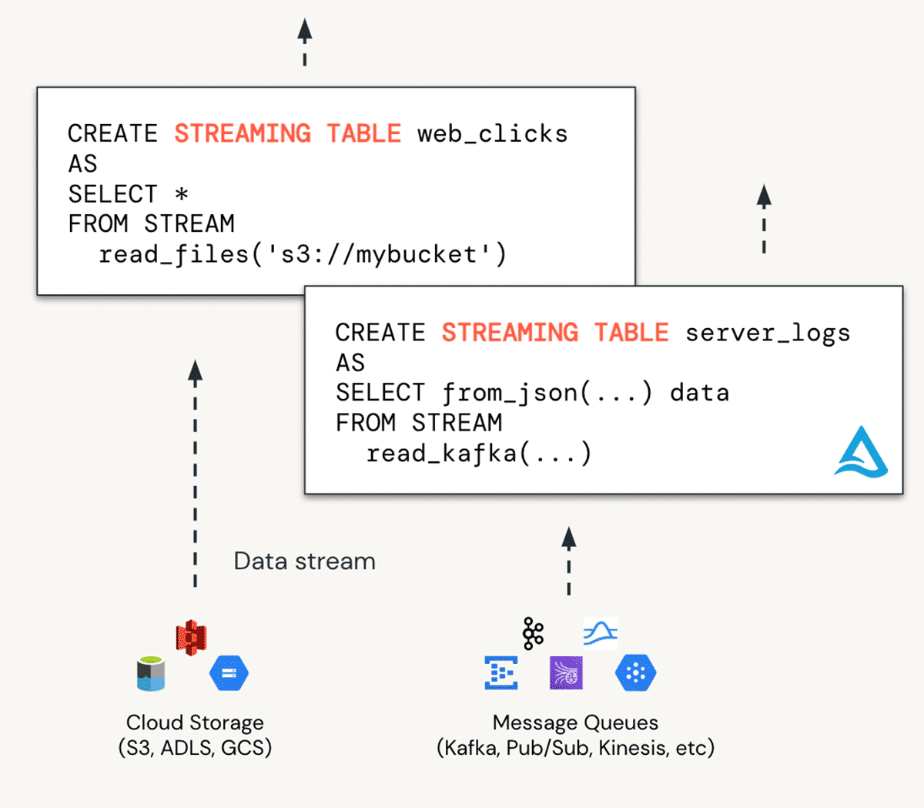
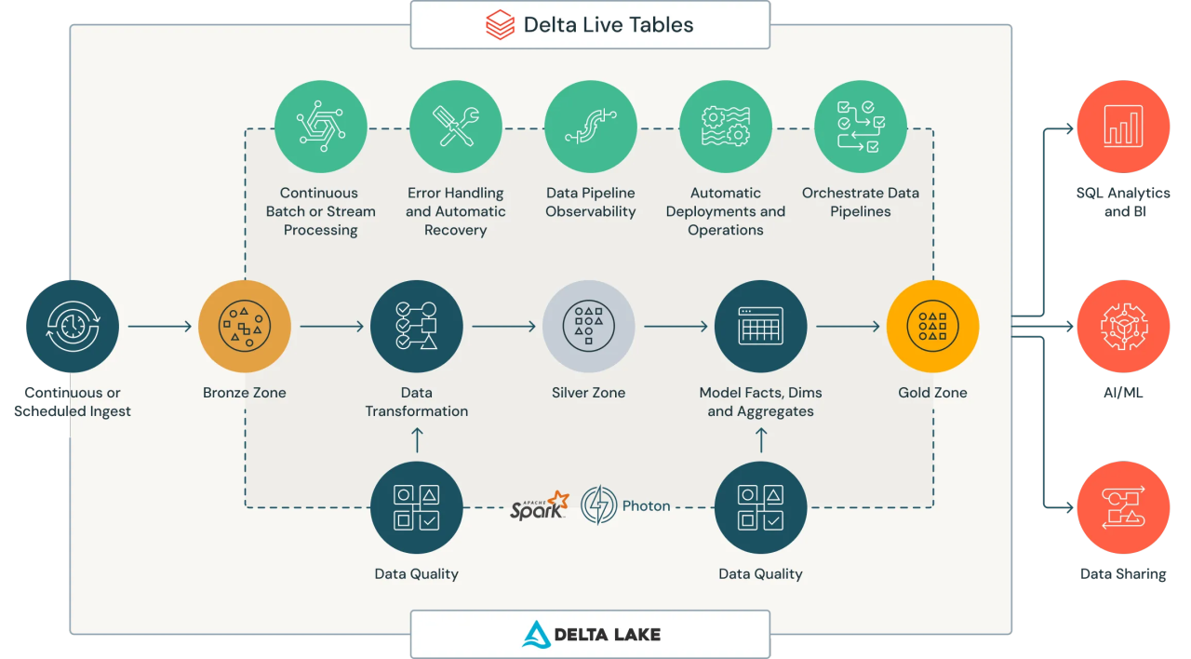

✔️ Simple Definition
A Streaming Table processes real-time or continuously arriving data.

✔️ Key Points
- Reads data using readStream
- Auto-updates when new files/messages arrive
- Keeps track of processed offsets
- Ideal for Kafka, Event Hub, autoLoader, streaming folders

✔️ Example
@dlt.table
def sales_stream():
return spark.readStream.format("json").load("/mnt/raw/sales")

⭐ 2. Materialized View (LIVE TABLE)
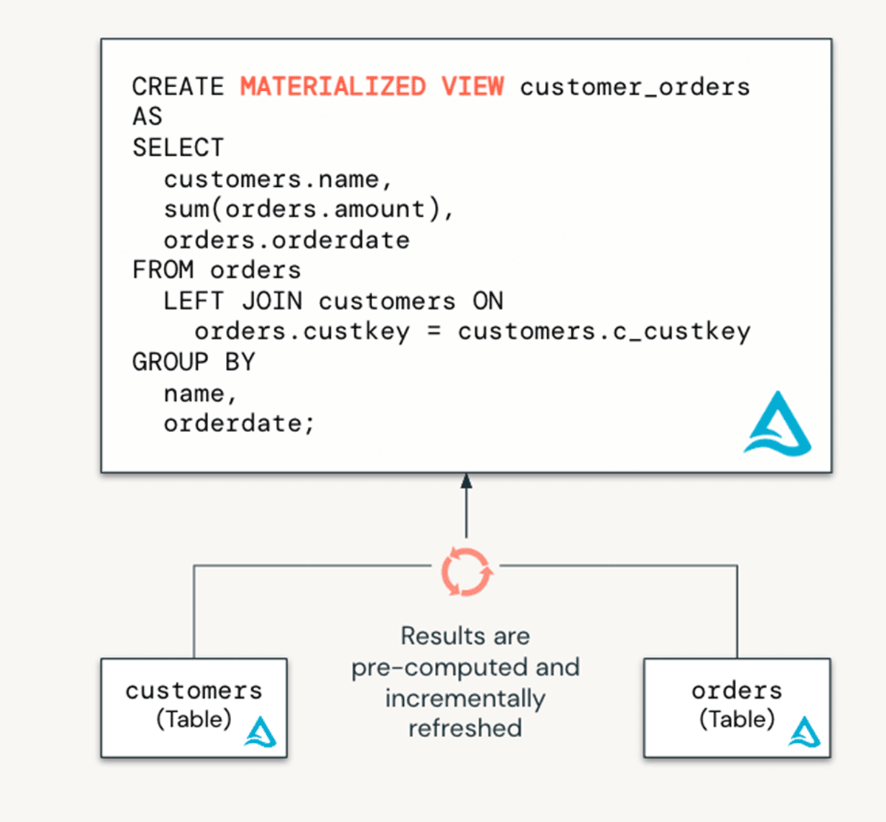
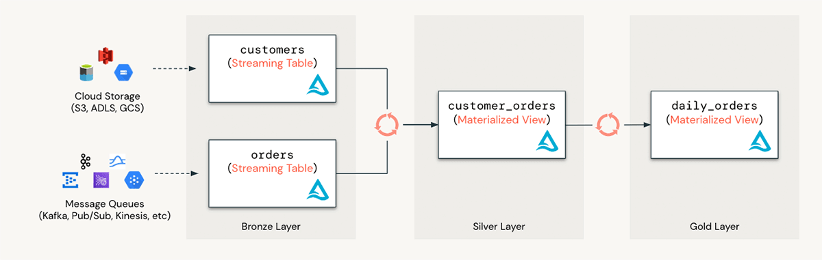

✔️ Simple Definition
A Materialized View is a managed, incrementally refreshed table.

✔️ Key Points
- Runs in batch/incremental mode
- Recomputes only changed data
- Used for cleanup, joins, aggregations
- Stores results permanently in Delta Lake

✔️ Example
@dlt.table
def clean_data():
return dlt.read("sales_stream").filter("amount > 0")

⭐ 3. View (LIVE VIEW)
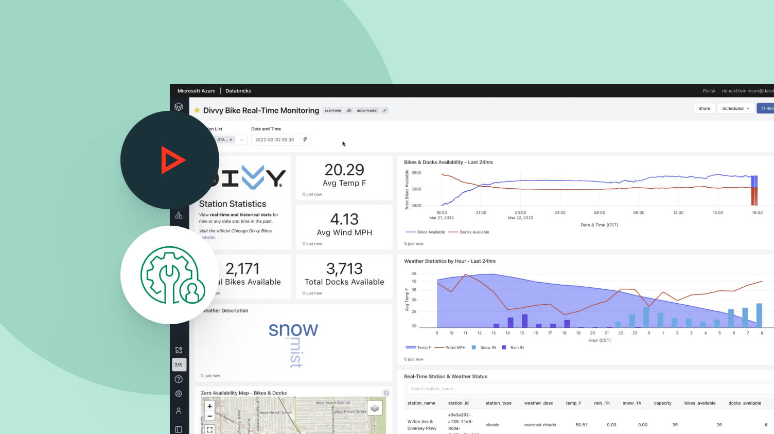
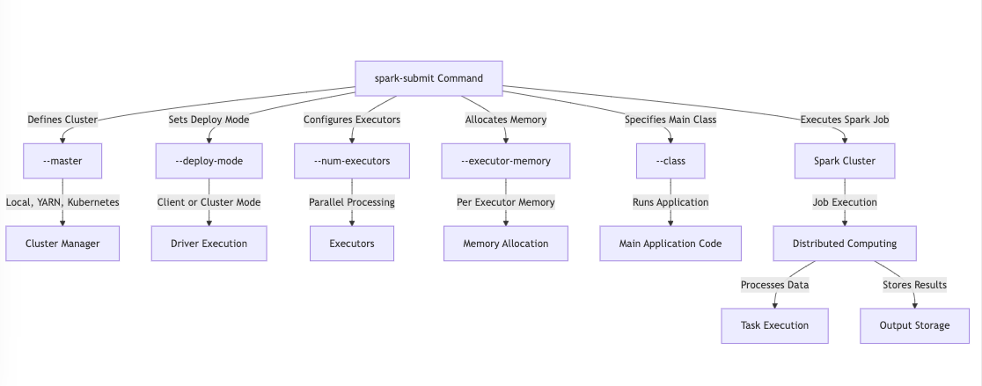

✔️ Simple Definition
A Live View is a logical view, not a stored table.

✔️ Key Points
- Does NOT store data
- Runs query every time another table uses it
- Good for intermediate logic to keep pipeline clean
- Lightweight, no storage cost

✔️ Example
@dlt.view
def joined_view():
return dlt.read("clean_data").join(dlt.read("products"), "id")

⭐ 4. Dataset (General DLT Dataset)

✔️ Simple Definition
Dataset is a general term for any DLT output:
- Streaming Table
- Materialized Table
- View
- Temporary View
Anything declared using @dlt.table or @dlt.view is called a dataset in SDP.

⭐ 5. Temporary View (Temp Dataset)
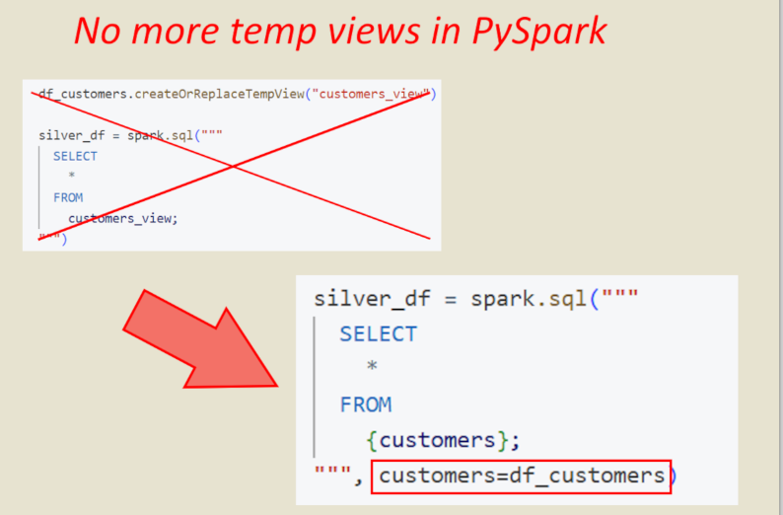
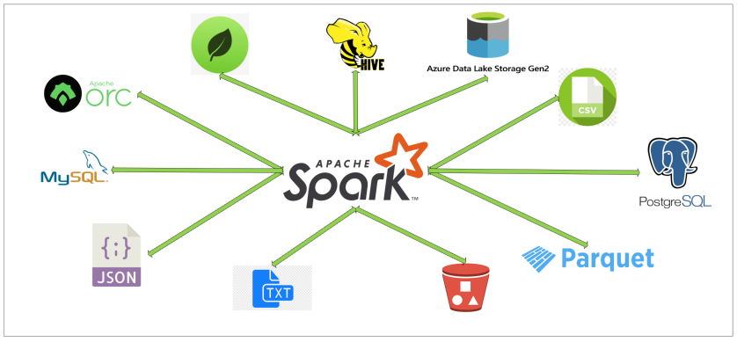

✔️ Simple Definition
A Temp View is a temporary table inside the notebook session only.

✔️ Key Points
- Not stored in storage
- Disappears when session ends
- Useful for debugging or SQL
- Not recommended for production pipelines

✔️ Example
df.createOrReplaceTempView("temp_sales")

⭐ 6. External Dataset (External Table)

✔️ Simple Definition
A dataset that comes from outside the pipeline, e.g.:
- ADLS
- S3
- Database tables
- Snowflake
- CSV/Parquet files

✔️ Key Points
- Used via dlt.read() or spark.read()
- Not managed by DLT
- Can be sources for DLT tables

✔️ Example
@dlt.table
def customers():
return spark.read.format("delta").load("/mnt/external/customers")

⭐ 7. Derived Dataset
A dataset created from another dataset through transformations.

✔️ Example
@dlt.table
def high_value_sales():
return dlt.read("clean_data").filter("amount > 10000")

📘 Quick Comparison Table
Dataset Type | Stored? | Updates Automatically? | Best For
Streaming Table | Yes | Real-time | Live streaming data
Materialized View | Yes | Incremental | Clean/transform batch data
Live View | No | Yes | Intermediate logic
Temp View | No | No | Testing/SQL queries
External Dataset | External | Depends on loader | Reading external data
Derived Dataset | Yes | Yes | Any DLT transformation

🎯 Final Summary
Spark Declarative Pipelines use different types of datasets to define how data is read, cleaned, stored, and refreshed.
You declare → Spark handles orchestration, optimization, and execution.

📘 What is a Pipeline? (Simple Definition)
A pipeline is a step-by-step flow of data, where data moves from
👉 raw source → cleaned data → transformed data → final output
Each step runs automatically in a fixed order.

✔️ In simple words:
A pipeline is an automated process that takes data in one end and gives clean, ready-to-use data on the other end.
Like a water pipeline → water enters dirty → gets filtered → comes out clean.
Data pipeline → raw data → transformations → clean data → reports.

⭐ Why Pipelines Are Used
Pipelines help in:
- Automating data processing
- Reducing manual work
- Maintaining consistent workflows
- Ensuring correct order of execution
- Handling large data efficiently
- Running daily, hourly, or real-time jobs
- Re-processing only new data

⭐ Types of Pipelines (Simple)

1️⃣ Batch Pipeline
Runs on schedule (daily/weekly).
Example: Daily sales report.

2️⃣ Streaming Pipeline
Processes data continuously (real-time).
Example: Live transaction monitoring.

3️⃣ Declarative Pipeline (SDP / DLT)
You write what you want, Spark runs everything automatically.

⭐ Pipeline in Spark (Very Simple)
A Spark pipeline is a sequence of data steps:
- Read raw data
- Clean it
- Transform it
- Store into final tables
Spark handles:
✔️ Scheduling
✔️ Dependency ordering
✔️ Optimization
✔️ Fault tolerance

🧠 Example (Simple)
A pipeline for sales data:
Step 1: Read raw files
Step 2: Clean missing values
Step 3: Filter wrong entries
Step 4: Join with product table
Step 5: Load final output table

Spark will run these steps automatically.

⭐ One-Line Summary
A pipeline is an automated flow that processes data step-by-step until it becomes ready for analysis or reporting.

nbb📘 Declarative Pipelines (DLT) – SCD Type 1

🔹 What is a Declarative Pipeline?
A Declarative Pipeline in Databricks is built using Delta Live Tables (DLT) where you declare WHAT you want, and Databricks handles HOW to execute it (orchestration, retries, quality, lineage).
👉 You focus on business logic, not infrastructure.

🔹 What is SCD Type 1?
Slowly Changing Dimension – Type 1:
- Overwrites old records with new values
- No history is maintained
- Only the latest data is stored
📌 Commonly used for:
- Name corrections
- Email updates
- Non-historical attributes

🔹 Why Use Declarative Pipelines for SCD-1?
- Built-in MERGE logic
- Automatic dependency handling
- Data quality enforcement
- Easy maintenance
- Production-ready pipelines

🔹 Key Concept: APPLY CHANGES INTO
DLT provides APPLY CHANGES INTO to handle SCD logic declaratively.
For SCD Type 1:
- Old records are updated
- New records are inserted
- No delete history

🔹 Architecture Flow
Source Data (Raw)
↓
Bronze Table (DLT)
↓
Silver Table (SCD Type 1)

🔹 Best Example: SCD Type 1 Using DLT

🔹 Source Data (Assume)
customer_id | name | city
1 | Rahul | Delhi
2 | Anita | Mumbai

Later update:
customer_id | name | city
1 | Rahul | Bangalore

➡ City gets updated, not stored as history.

🔹 Step 1: Create Bronze Table (Raw Ingestion)
import dlt
from pyspark.sql.functions import *

@dlt.table(
name="customers_bronze",
comment="Raw customer data"
)
def customers_bronze():
return spark.read.format("json") \
.load("/mnt/raw/customers")

🔹 Step 2: Create Silver Table with SCD Type 1
dlt.apply_changes(
target = "customers_silver",
source = "customers_bronze",
keys = ["customer_id"],
sequence_by = col("update_ts"),
stored_as_scd_type = 1
)

🔹 How This Works Internally
- DLT reads new records from source
- Matches records using primary key
- If key exists → UPDATE
- If key does not exist → INSERT
- Old values are overwritten
- Delta transaction log updated

🔹 What Happens When New Data Arrives?
Scenario | Result
New customer | INSERT
Existing customer updated | UPDATE
Same data | No change

🔹 SCD Type 1 vs Type 2 (Quick)
Feature | SCD-1 | SCD-2
History | ❌ No | ✔ Yes
Storage | Low | High
Query complexity | Simple | Complex
Use case | Corrections | Auditing

🔹 Benefits of Using DLT for SCD-1
- No manual MERGE code
- Built-in fault tolerance
- Automatic pipeline orchestration
- Lineage & monitoring UI
- Declarative and readable

🔹 Interview One-Minute Answer ⭐
Declarative pipelines in Databricks use Delta Live Tables to define data transformations. For SCD Type 1, we use apply_changes to overwrite existing records based on a primary key, ensuring the table always contains the latest data without maintaining history.

🔹 Key Takeaway ⭐⭐
DLT makes SCD-1 implementation simple, scalable, and production-ready using declarative logic.

If you want next:
- SCD Type 2 with DLT (deep dive)
- SCD 1 vs MERGE manually
- DLT expectations & data quality
- Interview questions on DLT

📘 Declarative Pipelines (DLT) – SCD Type 2

🔹 What is SCD Type 2?
Slowly Changing Dimension – Type 2:
- Preserves full history
- Inserts a new row when data changes
- Uses start_date / end_date / is_current columns
- Allows point-in-time analysis
📌 Common use cases:
- Address history
- Role changes
- Salary changes
- Auditing & compliance

🔹 Why Use Declarative Pipelines for SCD-2?
- No complex MERGE logic
- Automatic history handling
- Built-in validity columns
- Scalable & production-ready
- Clear, readable code

🔹 Key Concept: APPLY CHANGES INTO
For SCD Type 2, DLT automatically:
- Closes old records
- Inserts new versions
- Maintains history transparently

🔹 Architecture Flow
Source Data (Raw)
↓
Bronze Table (DLT)
↓
Silver Table (SCD Type 2)

🔹 Example Scenario

Initial Data
customer_id | name | city
1 | Rahul | Delhi

Updated Data
customer_id | name | city
1 | Rahul | Bangalore

Result in SCD-2 Table
customer_id | name | city | start_date | end_date | is_current
1 | Rahul | Delhi | 2024-01-01 | 2024-06-01 | false
1 | Rahul | Bangalore | 2024-06-01 | null | true

🔹 Step 1: Bronze Table (Raw Data)
import dlt
from pyspark.sql.functions import *

@dlt.table(
name="customers_bronze",
comment="Raw customer data"
)
def customers_bronze():
return spark.read.format("json") \
.load("/mnt/raw/customers")

🔹 Step 2: Silver Table with SCD Type 2
dlt.apply_changes(
target = "customers_silver",
source = "customers_bronze",
keys = ["customer_id"],
sequence_by = col("update_ts"),
stored_as_scd_type = 2
)

🔹 Columns Automatically Managed by DLT (SCD-2)
Column | Purpose
__START_AT | Record start timestamp
__END_AT | Record end timestamp
__IS_CURRENT | Current active record flag
📌 Column names may vary based on configuration.

🔹 How SCD-2 Works Internally
- Reads new data from source
- Matches records using primary key
- Detects data change
- Sets end_date for old record
- Inserts new record with updated values
- Marks new record as is_current = true

🔹 What Happens When New Data Arrives?
Scenario | Action
New key | INSERT
Changed record | EXPIRE old + INSERT new
Same data | No change

🔹 SCD-1 vs SCD-2 (Interview Favorite 🔥)
Feature | SCD-1 | SCD-2
History | ❌ No | ✔ Yes
Storage | Low | High
Query complexity | Simple | Medium
Auditing | ❌ | ✔

🔹 Best Practices ⭐
- Use proper sequence_by column
- Avoid frequent updates if not required
- Use SCD-2 only when history is needed
- Monitor table size growth

🔹 Interview One-Minute Answer ⭐
SCD Type 2 in Databricks Declarative Pipelines uses Delta Live Tables with apply_changes to preserve historical records. When data changes, the old record is expired and a new version is inserted, allowing full change tracking over time.

🔹 Key Takeaway ⭐⭐
DLT makes SCD-2 implementation simple, scalable, and reliable with minimal code.

